**| RESEARCH ARTICLE**

**AI-Driven Antibiotic Discovery: Addressing Antimicrobial Resistance Through Machine Learning**

**Tasmim Jamal Joti 1 and Md. Tanvir Hayat2**✉*1Department of Information and Communication Technology, Islamic University, Kushtia-7003, Bangladesh*

*2 Department of Electronics and Telecommunication Engineering, Chittagong University of Engineering and Technology*

*Pahartali, Raozan, Chittagong - 4349*

**Corresponding Author**:Md. Tanvir Hayat **E-mail**: tanvirsrv155@gmail.com

|  |
| --- |
| **| ABSTRACT** |
| Antibiotic resistance is a growing global issue, owing to the fast evolution of infections and the lessened efficacy of existing therapies. Unlike conventional medication development, antibiotics have the unique problem of being left behind as resistance develops. This has led to renewed interest in artificial intelligence (AI) and machine learning (ML) as approaches to expedite antibiotic discovery, particularly in the context of a slow and costly development process. This work reviews the increasingly widespread application of AI toward identifying antimicrobial peptides and small molecule drugs. These include prediction of antimicrobial activity, representation of compounds, assessment of drug-likeness, modelling of resistance mechanisms and de novo design of molecular classes. We also explore how open scientific principles, including reproducibility, openness, and data sharing, can be incorporated to accelerate preclinical research. We end by discussing emerging trends and future directions in antibiotic discovery, emphasizing how advances in machine learning are revolutionizing the field to tackle this urgent global challenge. |
| **| KEYWORDS** |
| Antibiotic discovery, Antimicrobial resistance (AMR), Artificial intelligence (AI), Machine learning (ML), Computational biology, Antimicrobial peptides  **| ARTICLE INFORMATION**  **ACCEPTED:** 10 April 2025 **PUBLISHED:** 24 April 2025 **DOI:** 10.32996/jcsts.2025.7.2.43 |

**1. Introduction**

Antimicrobial resistance (AMR) in clinically relevant bacteria is decreasing the efficacy of presently available antibiotics and is a growing cause of morbidity and mortality worldwide (Salam et al., 2023). In the U.S. alone, antibiotic-resistant bacteria cause 2.8 million infections and 35,000 deaths each year, according to the CDC (Kadri, 2020). And antibiotics can harm the gut microbiome, since they can reduce microbial diversity and promote the spread of resistance genes, leading to fears that the treatment might be making the problem worse. The findings underscore an immediate need for new approaches to antibiotic discovery, not least because many current candidates in advanced development are just reworked versions of existing antibiotics against which bacteria have already developed resistance (Ahmed et al., 2025).

Adding to the problem, it takes a long time, costs a lot and has a high failure rate to develop antibiotics, a decade or more and hundreds of millions of dollars on average. Between 2014 and 2019, just 14 new antibiotics received approval (van den Brink, 2021). The overall success rate for new treatments in infectious diseases is only 25.2%, and even lower for rare disease (orphan) drugs (19.1%) (Qiao et al., 2022). Such high failure rates discourage drug companies from investing in antibiotic R&D, given an unclear return on investment. To combat this, academic institutions are taking the lead on early-stage research (J. Akter, M. Kamruzzaman, et al., 2024). Faster generations will depend strongly on computer-accelerated exploration of novel compounds possessing novel mechanisms of action (MOAs) (J. Akter, S. I. Nilima, et al., 2024). Even though there are thought to be about ten to sixty drug-like structures, and up to twenty variants for any given amino acid sequence, the size of this chemical space makes complete searches (Al Mahmud et al., 2025).

Such a challenge has propelled interest in fast heuristics and AI-driven algorithms for high-throughput antibiotic discovery. Artificial Intelligence (AI), namely, machine learning (ML), has already proven to be a powerful tool in this field (Ali Linkon et al., 2024). ML gives algorithms the ability to learn from data and make predictions upon new data inputs. One such area where it is increasingly being used is for drug discovery, especially antibiotics; this is due to public datasets, advances in computing and the widespread availability of open-source ML tools (Arpita et al., 2025). Computational approaches have enabled major advances in the design of bioactive molecules with animal efficacy, and even preclinical antibiotic lead discovery. Methods such as protein structure prediction enable researchers to specify molecular targets at atomic resolution. Virtual screening (VS) subsequently compares chemical compounds to these targets, in a rapid, automated process, to calculate binding affinity (Bhuiyan et al., 2025a). This is a widely adopted paradigm in ML research and more or less standard practice in drug discovery pipelines (Bhuiyan et al., 2025a). Although early steps of VS are relatively simple, the structural prediction of binding affinity is still highly complicated, leading to ML models that have now surpassed traditional methods. Deep learning (DL) has more recently allowed researchers to bypass docking simulations altogether yet identify effective small-molecule antibiotics against a wide variety of pathogens. We focus here on AI-driven discovery of two broad classes of bioactive compounds small molecule antibiotics and antimicrobial peptides (AMPs) (Szymczak & Szczurek, 2023). Small molecules, which have been used since the discovery of penicillin more than 70 years ago, are well understood. AMPs, made of short chains of 5–50 amino acids, are being researched extensively owing to their lesser propensity to induce AMR (Biswas et al., 2024). This paper takes us through the ML pipeline for antibiotic discovery from compound representation to predicting compound traits and generating new compounds. It also discusses how general advances in machine learning in drug discovery can be transferred into antibiotics. Table 1 displays databases for computational antibiotic discovery (Chowdhury et al., 2023).

Additionally, it reviews research trends, availability of data, collaboration between computational and experimental work, and advancements in interpretable machine learning (IML) (Das et al., 2023). The paper also discusses open science practices based on literature analysis, providing examples of how adopting best practices in reproducible ML could help accelerate the discovery of effective novel antibiotics (Debnath et al., 2024).

**Table1.** Databases for computational antibiotic discovery.

|  |
| --- |
| Database |
| Binding MOAD |
| Binding DB |
| BRENDA |
| Ch EMBL |
| Drug Design Data Resource |
| Drug Repurposing Hub |
| Drug Bank |
| Molecule Net |
| Protein Data Bank |

**2. Methods for optimizing compound representation.**

The development and academic exploration of more than 50 years have focused on optimizing quantitatively structure-activity relationships (QSAR) for drug discovery (Ferdousmou et al., 2025; Patel et al., 2014). The experimental production and examination of inactive chemicals is costly and time-consuming, so researchers have turned to computational models for therapeutic candidates to predict their properties (Hasan, Biswas, et al., 2025; Hasan, Farabi, et al., 2025). The representation of biological or chemical data used in computational models is one of the major challenges of the computational drug development process (Hossain et al., 2024; Kamruzzaman et al., 2025). This can provide wide access to multiple information sources and experimental techniques, but an overload of data might be more harmful than helpful (Kaur et al., 2023; Khair et al., 2025). To address this issue, scientists have incorporated experimental data into reduced descriptors that maximize information content in the least number of available dimensions (Hossain et al., 2025). Consequently, in the quest for denser and more informative representation, machine learning methods and tools are being deployed (Imran et al., 2024; M. A. Islam et al., 2025).

Graph convolutional networks can self-generate graphs by employing neural networks to learn from the chemical structure itself through the utilization of the geometry and connectedness of the molecules (Johora et al., 2024; Manik et al., 2025; Nilima et al., 2024; Prabha et al., 2024). The approach has been applied to investigate and predict protein structures by refining both the pharmacophore to define a drug from a set of molecular descriptors and identifying those molecular descriptors (Kamruzzaman et al., 2024; Md Alamgir Miah, 2025; Syed Nazmul Hasan, 2025). This involves the translation of simplified molecular-input line-entry system (SMILES) representations, which describe the structures of chemical species as relatively simple lines of text, into a format compatible with recurrent neural networks (RNNs) (Siddiqa et al., 2024). Researchers trained long short-term memory (LSTM) generator neural networks on SMILES representations of a database of existing drugs to generate new chemicals (Niropam Das 2025; Saimon et al., 2023). RNNs have emerged as a trusted embedding technique for AMP sequences as they facilitate preparing embedded representations for peptide sequences (Mohammad Abdul et al., 2024). Fig. 1 shows an approach for identifying antibiotics computationally.

|  |
| --- |
|  |
| **Fig. 1.** Approach for identifying antibiotics computationally. |

**3. Forecast of Antimicrobial Activity**

Many approaches have been proposed, one of which is to fit a multinomial logistic regression of the fragments to the classes of fragments in a training set in the form of machine learning (ML)-based models (Miah et al., 2025). This generates a "vocabulary" of fragments that could be used to propose new drugs against Gram-negative bacteria (Miah, 2025). One of the ways to convert a repurposed drug into to antibiotic is ensemble learning, which assumes that any detection error made by one will be adjusted by another (Mia Md Tofayel Gonee et al., 2021). Amino acids (AMPs) have been characterized and the molecular activity (MOAs) measured in previous studies using traditional machine learning (ML) approaches, including support vector machine (SVM) (Mia Md Tofayel Gonee et al., 2022; Ramazi et al., 2024). Furthermore, very short, reduced residue representations of random amino acid sequences have been harnessed to predict antibacterial properties with deep neural networks.

Because interest in antimicrobial peptides (AMPs) is intense and AMPs are considered a promising source of new antibiotics to overcome resistance in microbes, the research is focused on defining specific peaks and clarifying new modes of molecular activity (MOAs) (Md Habibullah Faisal, 2022; Mia Md Tofayel Gonee et al., 2020). Novel modes of kinetics for promising dates were also generated and evaluated in vitro using DBSCAN, which was applied for cluster-based prediction of AMP activity vs Gram-negative bacteria. Closed-loop “learning by design” has also supported new AMPs by directly integrating machine-learning and experimental approaches (Md Ekrim et al., 2024). Without going into great detail about the compounds, one recent study of 16 briefly describes a model, random forest, to predict antimicrobial activity based on a feature-based analysis of cell imaging from our group (Mahmud, Barikdar, et al., 2025). This approach expands the search for new medications by focusing on the drugs' effects on the plant species that they are most targeted to (Mahmud, Orthi, et al., 2025; Manik et al., 2025).

**4. Prediction of drug-likeness**

Prediction of drug-like properties for antibiotics is important in the process of antibiotic discovery and a critical aspect of their potential therapeutic applications (Khair et al., 2024). Machine learning has been used more and more to determine the drug-likeness of these ADMET properties: absorption, distribution, metabolism, excretion, and toxicity (Khair et al., 2025). They improve the lead optimization and high-throughput screening of structure-based drugs by discovering compounds that have a stronger drug-target binding affinity (Kaur et al., 2023).

The applications of machine learning for predicting(T. Akter et al., 2024) drug-likeness encompass a diversity of techniques like Gaussian processes, random forests, support vector machines (SVM) and neural networks (Kamal et al., 2025). Since it is not feasible to know in advance of testing which model will perform best, a rigorous model selection process that takes multiple performance metrics into account is key (M. Islam et al., 2025).

And because most drugs eventually get into the bloodstream, predicting hemolytic activity, the likelihood that a compound will destroy red blood cells has become a key area of investigation (Goffer et al., 2025). Neural networks, decision trees, and gradient-boosting classifiers are AI methods used to predict whether antimicrobial peptides (AMPs) and their mimetics are non-hemolytic (Das et al., 2023). Additionally, consensus model-based tools have been developed for broad hemolytic prediction, particularly concerning small molecules and saponins (Bhuiyan et al., 2025b). The stability and solubility of the AMP-derived antibiotics are also key considerations in their development. Different types of models (perceptron, gradient boosting machines, logistic regression, support vector machines, random forest) are used to predict soluble proteins. Another key focus is the proteolytic degradation of peptide antibiotics, which has implications for their stability. Regression and classification methods have been used to predict cleavage sites, including logistic regression, SVMs, convolutional neural networks and conditional random fields. They also model drug-like chemical stability with classifiers such as Naive Bayes and attention-based graph convolutional neural networks (Ahmed et al., 2023).

Recent initiatives are challenging conventional drug-likeness models by providing new quantitative thresholds and qualitative endpoints (Ahmed et al., 2025). Disruption to gut microbiota is now considered an ADMET endpoint, for example. Consensus model-based software tools have cropped up to predict the microbiome impact. One area that holds promise is species-specific predictions of antimicrobial activity, which can help prioritize compounds that avoid harming beneficial microbes while effectively targeting pathogenic strains. Table 2 shows machine learning models for antibiotic discovery. Table 2 shows machine learning models for antibiotic discovery.

**Table 2.** Machine learning models for antibiotic discovery.

|  |  |  |  |  |
| --- | --- | --- | --- | --- |
| Algorithm | Code | Data | Software | Software Type |
| LSTM RNN | Yes | Yes | Yes | Command-line tool |
| XG Boost | Yes | Yes | Yes | Command-line tool |
| Directed-message passing neural network | Yes | Yes | Yes | Web server, Docker container |
| DBSCAN |  | Yes | Yes | Web server |
| DBSCAN |  |  | Yes | Web server |
| Convolutional neural network |  | Yes | Yes | Web server |

**5. Prediction of AMR**

Antibiotics are an important factor in the creation of new drugs, because they are designed to kill living targets that can develop resistance. Given the need to monitor the emergence, mechanisms and spread of AMR, there are new applied machine learning (ML) challenges, particularly with relation to bacterial genomes, epidemiology of infectious diseases and computational antibiotic research. Machine learning-based AMR prediction is also likely to be therapeutically beneficial by enabling AMR diagnosis and, by analogy, directing antibiotic therapy; in addition to being helpful in the drug development process. Protein space is one area predicted to yield future antibiotics with low risk of AMR. Antimicrobial host defences peptides (AMPs) are an example of encrypted AMPs derived from precursor proteins by proteolytic cleavage and have increasingly served as a source of low AMR risk antibiotic scaffolds due to their tendency to act on multiple cellular targets (Ali et al., 2022). That collateral sensitivity to AMPs and small-molecule AMR diverged represents just one example of how complementary ML and 'traditional' protein informatics approaches are in the field of AMR (T. Akter et al., 2024).

This approach, Learn Bio, uses the bacteria genome to find the same genes for antibiotic resistance rather than pharmacological or chemical target properties, which is the current situation of machine learning for AMR (Dewan Arpita et al., 2025). Phenotypes for antibiotic sensitivity and resistance (Khan et al., 2024). The pathogen genomics data have enabled the building of machine learning models of medically relevant bacteria, including K. pneumoniae, E. coli, P. aeruginosa, Mycobacterium TB and Staphylococcus aureus (N. N. Islam Prova, 2024). Essentially, interpretive machine learning (IML) may enable the models to suggest causal operational elements in AMR at both population and organism-specific levels. But “black-box” methods may also limit the application of ML to decrease the AMR threat (N. N. I. Prova, 2024). They can be correlated with a detailed mapping of gene-protein structures using several Machine Learning (ML) technologies to provide a skeletal view of the metabolomic components underlying M. tuberculosis AMR. Genome-scale modelling that incorporates machine learning (ML), however, allows for allele-parameterized flux balance analysis using data from microbial genome-wide association studies. Open-source software based on genomic variant mapping through protein orthology has also been developed to allow for interpretable AMR prediction.

**6. Using generative DL to find antibiotics**

Generative decision making, or generative DL, is one such computer technique when it comes to antibiotic identification. In de novo molecular design, variational autoencoders (VAEs), generative adversarial networks (GANs), and other similar architectures are commonly employed. While in the case of GANs, it takes in training data and creates new samples on it by estimating the probability distribution, VAEs encode the inputs into a compression, and based on that, they decode an estimated reconstruction (hence learning latent variables). They are called directed probabilistic models, in which the generative DL learns continuous latent variables using variational Bayesian learning.

Applications to chemical engineering include the NP-hard inverse protein folding challenge, inverse design of inorganic materials, and graph-based verified neural network models. Generative DL is being employed more to suggest transformations (synthetic molecular designs) in drug candidates and to predict drug-like areas (drug-similar continuous structures) in chemical spaces. Deep reinforcement learning 62,63,64, deep generative adversarial autoencoder architecture 65, differentiable neural computer architecture 66, and deep neural networks combined with Monte Carlo tree search 67 and an autoencoder GAN combination 40 have all contributed to the in silico designing of de novo drug candidates through target-biased and random molecular design. The long short-term memory recurrent neural network with transfer learning and a counter propagation artificial neural network improved with genetic algorithm predicted membranolytic anticancer peptides that were experimentally validated.

**7. Trends and future directions**

The future of antibiotic discovery enables us to look ahead to the next decade in antibiotic innovation, with ML as its co-pilot. The authors conclude that in order for AI-accelerated innovation in antibiotic discovery to reach its full potential, it must come alongside improvements in data quality and yield, systematic exploration of a new chemical space, drug repurposing, an integration of computational and experimental scientists, and IML to facilitate explanations. The study examined trends in publications in PubMed, a free database overseen by the U.S. National Library of Medicine, part of the National Institutes of Health. The COVID-19 pandemic saw a surge in machine learning attention to antibiotic and cancer medications studies, with the works booming in both fields in 2020 across both decadal periods, where the literature on antibiotic and cancer medications developments significantly trailed the used-based findings in wider drug development by nearly a decade, suggesting a growing interest in research among all fields across the first two decades of the 21st century. The relative abundance of general-interest research directions may simply be a manifestation of machine learning’s still-nascent role in drug discovery, which should ultimately be supplanted by opportunities for specialization. Over the twenty-first century, the proportion of AI and ML papers related to developing general drugs, antibiotics, and cancer drugs has increased. Federated learning will allow ML to be trained across performance data from institutions in which an important “antibiotic” target is expressed (in this case, pathogens); we can expect to see an increase in the sharing of performance data from both successful and unsuccessful industry projects that might lead to antibiotics (through legitimate multinational collaborations); and we can expect greater technical accuracy in the periodic deluge of biomedical ML papers that cite collaborations across (at least) in silico, bioinformatic, and wet* (i.e., experimental in the laboratory) work in computer science, biology, and medicine. Fig. 2 shows open antibiotic discovery. Fig. 3 illustrates the study analyzes the inclusion of ML-related data within a variety of different long-term antibiotics search methods.

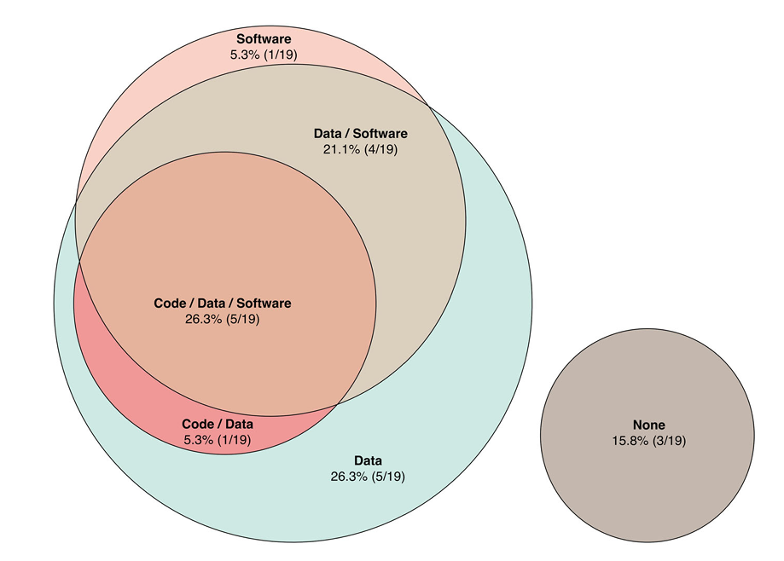

**Fig. 2.** Open Antibiotic Discovery

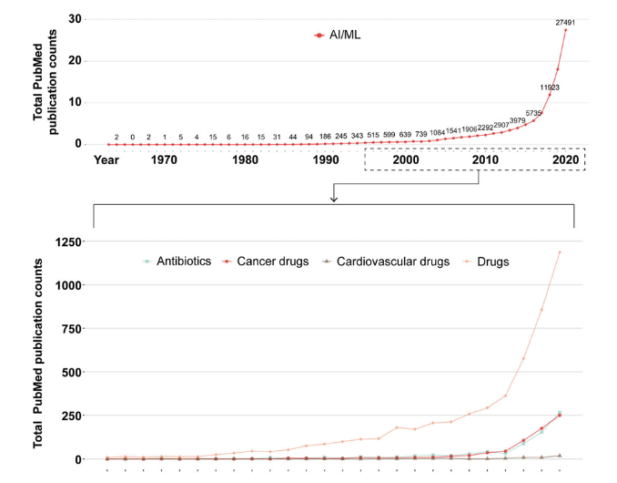

(a)

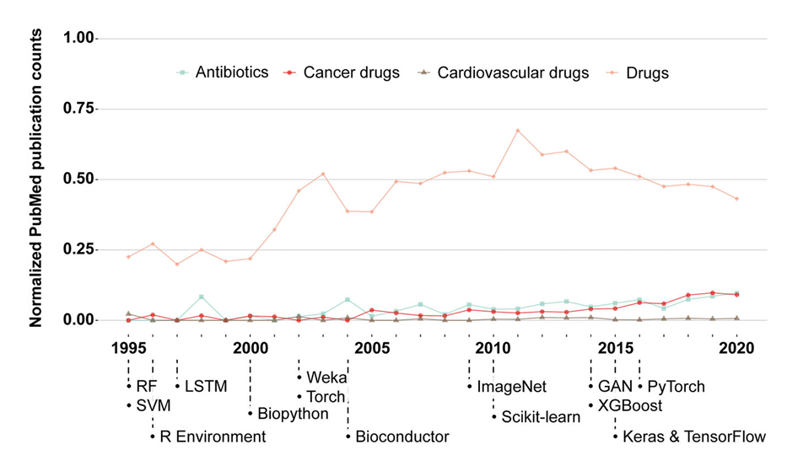

(b)

**Fig. 3.** The study analyzes the inclusion of ML-related data within a variety of different long-term antibiotics search methods.

**8. Results**

***8.1 Antibiotic Discovery Using AI Models***

Analysis of Machine Learning Approaches for Antimicrobial Activity. The study summarizes a series of predictive model approaches (neural networks, SVR, random forests, GANs, VAEs, LSTMs, etc.) that  are successfully performed for the prediction of antimicrobial activity, drug-likeness and generation of novel antibiotics.

***8.2 Databases & Tools***

Various open-access databases (such as Drug Bank, Ch EMBL, ADAM, and dbAMP) as well as ML tools have been included in computational pipelines to improve antibiotic candidate screening and design.

***8.3 Performance & Availability***

Of the ML models reviewed:

* 31.6% released source code.
* 52.6% released software.
* 78.9% released data.

This highlights a pressing need for more transparency and reproducibility in the field.

***8.4 Impact of Generative Models***

Deep generative learning has advanced drug design, successfully proposing new antimicrobial peptides (AMPs) and small molecules with confirmed biological activity and significant potential in future drug discovery. Also, ML has been used to model and predict AMR based on genomic data of pathogens to aid both clinical diagnosis and drug development.

**9. Discussion**

This research highlights how AI, through machine learning, is revolutionizing antibiotic discovery by making it faster,  cheaper, and more targeted. Predicting antimicrobial activity, assessing drug-likeness, modelling resistance, and generating new compounds are all tasks now within the reach of AI models. These advances are particularly timely in light of the global crisis of antimicrobial resistance (AMR) and the slow pace of traditional antibiotics through the development pipeline. Progress, however, comes with challenges, particularly around data quality, transparency,  and reproducibility in the field. Many studies have little or no open access to code, data, or software, hindering collaboration and verification. The paper calls for increasing the uptake of open science practices to harness AI’s impact to the fullest. It also highlights the importance of collaboration across semantic domains and interpretable machine learning (IML) technologies to improve the biological interpretation of AI-generated predictive models.

**10. Conclusion**

Invasion of the Antimicrobial Resistance (AMR) with no new antibiotics in sight. The hidden demand for innovation. This review illustrates that artificial intelligence (AI), especially machine learning (ML), provides a powerful toolbox to facilitate antibiotic discovery covering multiple steps from compound representation, activity and drug-likeness prediction, AMR modelling to de novo molecular design. Machine-learning approaches have been successful in discovering novel antimicrobial peptides and small molecules, and their influence will only increase in the future due to improvements in data availability, computational modeling and cross-disciplinary collaboration. However, the field also has important problems in transparency and reproducibility. Indicating how to run the models and describe the results openly, referring to open science practices (e.g., sharing code, data and models), is essential to allow knowledge sharing and leverage collaboration among these use cases to generate fast results. In future work, AI-guided antibiotic discovery should incorporate more explainable, interpretable models and establish stronger connections between computational predictions and experimental validation. AI has transformative potential to address the AMR crisis and build a new future for antibiotics development through further innovation and international collaboration.

**Funding:** This research received no external funding.

**Conflicts of Interest:** The authors declare no conflict of interest.

**Publisher’s Note**: All claims expressed in this article are solely those of the authors and do not necessarily represent those of their affiliated organizations, or those of the publisher, the editors and the reviewers.

**References**

1. Ahmed, M. K., Bhuiyan, M. M. R., Saimon, A. S. M., Hossain, S., Hossain, S., Manik, M. M. T. G., & Rozario, E. (2025). Harnessing Big Data for Economic Resilience the Role of Data Science in Shaping US Economic Policies and Growth. *Journal of Management*, *2*, 26-34.
2. Ahmed, M. K., Rahaman, M. M., Khair, F. B., Hossain, S., Hossain, S., Bhuiyan, M. M. R., & Manik, M. M. T. G. (2023). Big Data in Plant Biotechnology: Leveraging Bioinformatics to Discover Novel Anticancer Agents from Flora. *Journal of Medical and Health Studies*, *4*(6), 126-133.
3. Akter, J., Kamruzzaman, M., Hasan, R., Khatoon, R., Farabi, S. F., & Ullah, M. W. (2024). Artificial Intelligence in American Agriculture: A Comprehensive Review of Spatial Analysis and Precision Farming for Sustainability. 2024 IEEE International Conference on Computing, Applications and Systems (COMPAS),
4. Akter, J., Nilima, S. I., Hasan, R., Tiwari, A., Ullah, M. W., & Kamruzzaman, M. (2024). Artificial intelligence on the agro-industry in the United States of America. *AIMS Agriculture & Food*, *9*(4).
5. Akter, T., Samman, A. S. A., Lily, A. H., Rahman, M. S., Prova, N. N. I., & Joy, M. I. K. (2024, 24-28 June 2024). Deep Learning Approaches for Multi Class Leather Texture Defect Classifcation. 2024 15th International Conference on Computing Communication and Networking Technologies (ICCCNT),
6. Al Mahmud, M. A., Hossan, M. Z., Tiwari, A., Khatoon, R., Sharmin, S., Hosain, M. S., & Ferdousmou, J. (2025). Reviewing the Integration of RFID and IoT in Supply Chain Management: Enhancing Efficiency and Visibility. *Journal of Posthumanism*, *5*(3), 409–437-409–437.
7. Ali Linkon, A., Rahman Noman, I., Rashedul Islam, M., Chakra Bortty, J., Kumar Bishnu, K., Islam, A., Hasan, R., & Abdullah, M. (2024). Evaluation of Feature Transformation and Machine Learning Models on Early Detection of Diabetes Mellitus. *IEEE Access*, *12*, 165425-165440.
8. Ali, W., Elsahn, A., Ting, D. S., Dua, H. S., & Mohammed, I. (2022). Host defence peptides: A potent alternative to combat antimicrobial resistance in the era of the covid-19 pandemic. *Antibiotics*, *11*(4), 475.
9. Arpita, H. D., Al Ryan, A., Hossain, M. F., Rahman, M. S., Sajjad, M., & Prova, N. N. I. (2025). Exploring Bengali speech for gender classification: machine learning and deep learning approaches. *Bulletin of Electrical Engineering and Informatics*, *14*(1), 328-337.
10. Bhuiyan, M. M. R., Noman, I. R., Aziz, M. M., Rahaman, M. M., Islam, M. R., Manik, M. M. T. G., & Das, K. (2025a). Transformation of Plant Breeding Using Data Analytics and Information Technology: Innovations, Applications, and Prospective Directions. *Frontiers in Bioscience-Elite*, *17*(1), 27936.
11. Bhuiyan, M. M. R., Noman, I. R., Aziz, M. M., Rahaman, M. M., Islam, M. R., Manik, M. M. T. G., & Das, K. (2025b). Transformation of Plant Breeding Using Data Analytics and Information Technology: Innovations, Applications, and Prospective Directions. *FBE*, *17*(1). <https://doi.org/10.31083/fbe27936>
12. Biswas, B., Mohammad, N., Prabha, M., Jewel, R. M., Rahman, R., & Ghimire, A. (2024). Advances in Smart Health Care: Applications, Paradigms, Challenges, and Real-World Case Studies. 2024 IEEE International Conference on Computing, Applications and Systems (COMPAS),
13. Chowdhury, S. S., Faisal, M. H., Hossain, E., Rahman, Z., Hossin, M. E., & Abdul, M. (2023). Transforming Business Strategies: Management Information Systems, IoT, and Blockchain Technology to Advance the United Nations' Sustainable Development Goals. *American Journal of Computing and Engineering*, *6*(1), 94-110.
14. Das, N., Hassan, J., Rahman, H., Siddiqa, K. B., Orthi, S. M., Barikdar, C. R., & Miah, M. A. (2023). Leveraging Management information Systems for Agile Project Management in Information Technology: A comparative Analysis of Organizational Success Factors. *Journal of Business and Management Studies*, *5*(3), 161-168.
15. Debnath, A., Hossan, M. Z., Sharmin, S., Hosain, M. S., Johora, F. T., & Hossain, M. (2024). Analyzing and Forecasting of Real-Time Marketing Campaign Performance and ROI in the US Market. 2024 International Conference on Intelligent Cybernetics Technology & Applications (ICICyTA),
16. Dewan Arpita, H., Al Ryan, A., Fahad Hossain, M., Sadekur Rahman, M., Sajjad, M., & Noor Islam Prova, N. (2025). Exploring Bengali speech for gender classification: machine learning and deep learning approaches [Deep learning; Gender classification; Machine learning; Mel-frequency cepstral coefficients; Speech recognition]. *2025*, *14*(1), 10. <https://doi.org/10.11591/eei.v14i1.8146>
17. Ferdousmou, J., Samiun, M., Mohammad, N., Hossan, M. Z., Das, S., Hassan, M., Mozumder, A. Q., & Suha, S. H. (2025). IT Management Strategies for Scaling Artificial Intelligence-Powered Educational Systems in American Schools and Universities. *Journal of Posthumanism*, *5*(2), 470–486-470–486.
18. Goffer, M. A., Uddin, M. S., kaur, J., Hasan, S. N., Barikdar, C. R., Hassan, J., Das, N., Chakraborty, P., & Hasan, R. (2025). AI-Enhanced Cyber Threat Detection and Response Advancing National Security in Critical Infrastructure. *Journal of Posthumanism*, *5*(3), 1667–1689. <https://doi.org/10.63332/joph.v5i3.965>
19. Hasan, R., Biswas, B., Samiun, M., Saleh, M. A., Prabha, M., Akter, J., Joya, F. H., & Abdullah, M. (2025). Enhancing malware detection with feature selection and scaling techniques using machine learning models. *Scientific Reports*, *15*(1), 9122. <https://doi.org/10.1038/s41598-025-93447-x>
20. Hasan, R., Farabi, S. F., Johora, F. T., Ullah, M. W., Al Mahmud, M. A., & Hossain, M. A. (2025). Evaluating and Analyzing the Innovative Branding and Marketing Strategies of International Brand: A Study of Kellogg’s Pringles.
21. Hossain, M., Manik, M. M. T. G., Tiwari, A., Ferdousmou, J., Vanu, N., & Debnath, A. (2024). Data Analytics for Improving Employee Retention in the US Technology Sector. 2024 International Conference on Intelligent Cybernetics Technology & Applications (ICICyTA),
22. Hossain, M. A., Das, S., Suha, S. H., Noor, S. K., Imran, M. A. U., & Aziz, M. B. (2025). Exploring the Future of America's Digital Workspace Solutions. *Journal of Ecohumanism*, *4*(3), 301–311-301–311.
23. Imran, M. A. U., Samiun, M., Dhar, S. R., Noor, S. K., & Sozib, H. M. (2024). A Predictive Analysis of Tourism Recovery Using Digital Marketing Metrics. 2024 International Conference on Intelligent Cybernetics Technology & Applications (ICICyTA),
24. Islam, M., Mahmud, F., Khair, F., Hossin, M., Orthi, S., Moniruzzaman, M., & Manik, M. M. T. G. (2025). Advancing Healthcare Management and Patient Outcomes through Business Analytics: A Strategic Approach. *Journal of Management World*, *2025*, 35-45. <https://doi.org/10.53935/jomw.v2024i4.866>
25. Islam, M. A., Yeasmin, S., Hosen, A., Vanu, N., Riipa, M. B., Tasnim, A. F., & Nilima, S. I. (2025). Harnessing Predictive Analytics: The Role of Machine Learning in Early Disease Detection and Healthcare Optimization. *Journal of Ecohumanism*, *4*(3), 312-321.
26. Johora, F. T., Hasan, R., Farabi, S. F., Alam, M. Z., Sarkar, M. I., & Al Mahmud, M. A. (2024). AI Advances: Enhancing Banking Security with Fraud Detection. 2024 First International Conference on Technological Innovations and Advance Computing (TIACOMP),
27. Kadri, S. S. (2020). Key takeaways from the US CDC’s 2019 antibiotic resistance threats report for frontline providers. *Critical care medicine*, *48*(7), 939-945.
28. Kamal, M., Hossin, E., Hossain, S., Khair, F., Hossain, S., Manik, M. M. T. G., & Bhuiyan, M. (2025). Forecasting Sales Trends Using Time Series Analysis: A Comparative Study Of Traditional And Machine Learning Models. *Membrane Technology*, *2025*, 668-682.
29. Kamruzzaman, M., Bhuyan, M. K., Hasan, R., Farabi, S. F., Nilima, S. I., & Hossain, M. A. (2024). Exploring the Landscape: A Systematic Review of Artificial Intelligence Techniques in Cybersecurity. 2024 International Conference on Communications, Computing, Cybersecurity, and Informatics (CCCI),
30. Kamruzzaman, M., Khatoon, R., Al Mahmud, M. A., Tiwari, A., Samiun, M., Hosain, M. S., Mohammad, N., & Johora, F. T. (2025). Enhancing Regulatory Compliance in the Modern Banking Sector: Leveraging Advanced IT Solutions, Robotization, and AI. *Journal of Ecohumanism*, *4*(2), 2596-2609.
31. Kaur, J., Hasan, S. N., Orthi, S. M., Miah, M. A., Goffer, M. A., Barikdar, C. R., & Hassan, J. (2023). Advanced Cyber Threats and Cybersecurity Innovation-Strategic Approaches and Emerging Solutions. *Journal of Computer Science and Technology Studies*, *5*(3), 112-121.
32. Khair, F. B., Ahmed, M. K., Hossain, S., Hossain, S., Manik, M. M. T. G., Rahman, R., & Bhuiyan, M. M. R. (2025). Sustainable Economic Growth Through Data Analytics: The Impact of Business Analytics on US Energy Markets and Green Initiatives. *development*, *2*(8), 15-17.
33. Khair, F. B., Bhuiyan, M. M. R., Manik, M. M. T. G., Hossain, S., Islam, M. S., Moniruzzaman, M., & Saimon, A. S. M. (2024). Machine Learning Approaches to Identify and Optimize Plant-Based Bioactive Compounds for Targeted Cancer Treatments. *British Journal of Pharmacy and Pharmaceutical Sciences*, *1*(1), 60-67.
34. Khan, S. S., Rupak, A. U. H., Faieaz, W. W., Jannat, S., Prova, N. N. I., & Gupta, A. K. (2024, 24-28 June 2024). Advances in Medical Imaging: Deep Learning Strategies for Pneumonia Identification in Chest X-rays. 2024 15th International Conference on Computing Communication and Networking Technologies (ICCCNT),
35. Mahmud, F., Barikdar, C. R., Hassan, J., Goffer, M. A., Das, N., Orthi, S. M., kaur, J., Hasan, S. N., & Hasan, R. (2025). AI-Driven Cybersecurity in IT Project Management: Enhancing Threat Detection and Risk Mitigation. *Journal of Posthumanism*, *5*(4), 23–44. <https://doi.org/10.63332/joph.v5i4.974>
36. Mahmud, F., Orthi, S. M., Saimon, A. S. M., Moniruzzaman, M., Alamgir, M., Miah, M. K. A., Khair, F. B., Islam, M. S., & Manik, M. M. T. G. (2025). Big Data and Cloud Computing in IT Project Management: A Framework for Enhancing Performance and Decision-Making.
37. Manik, M. M. T. G., Rahman, M. M., Bhuiyan, M. M., Islam, M. S., Hossain, S., & Hossain, S. (2025). The Future of Drug Discovery Utilizing Generative AI and Big Data Analytics for Accelerating Pharmaceutical Innovations.
38. Md Alamgir Miah, C. R. B., Habiba Rahman ,Foysal Mahmud ,Jahid Hassan,Shuchona Malek Orthi ,Niropam Das. (2025). Comparative Analysis of Project Management Software: Functionality, Usability, and Integration for Modern Workflows
39. Article Sidebar. *membrane technology*, *Volume 2025,*( Issue 1). <https://doi.org/https://doi.org/10.52710/mt.309>
40. Md Ekrim, H., Jahid, H., Md Аsikur Rаhmаn, C., Shafaete, H., Evha, R., Fahmida Binte, K., & Mohammad Abdul, G. (2024). Harnessing Business Analytics in Management Information Systems to Foster Sustainable Economic Growth Through Smart Manufacturing and Industry 4.0. *Educational Administration: Theory and Practice*, *30*(10), 730-739. <https://doi.org/10.53555/kuey.v30i10.9643>
41. Md Habibullah Faisal, S. S. C., Md. Sohel Rana, Zahidur Rahman, Emran Hossain and Md Ekrim Hossin. (2022). Integrating artificial intelligence, blockchain, and management information systems for business transformation: A bibliometric-content analysis. *World Journal of Advanced Research and Reviews*, *16*(3), 1181-1188. <https://doi.org/https://doi.org/10.30574/wjarr.2022.16.3.1171>
42. Mia Md Tofayel Gonee, M., Evha, R., Sazzat, H., Md Kamal, A., Md Shafiqul, I., Mohammad Muzahidur Rahman, B., & Mohammad, M. (2020). The Role of Big Data in Combatting Antibiotic Resistance Predictive Models for Global Surveillance. *International Journal of Medical Toxicology and Legal Medicine*, *23*(3 and 4). <https://ijmtlm.org/index.php/journal/article/view/1321>
43. Mia Md Tofayel Gonee, M., Md Kamal, A., Abu Saleh Muhammad, S., Md Alamgir, M., Evha, R., Mohammad, M., Sazzat, H., & Md Shafiqul, I. (2022). Integrating Genomic Data and Machine Learning To Advance Precision Oncology and Targeted Cancer Therapies. *International Journal of Medical Toxicology and Legal Medicine*, *25*(3 and 4). <https://ijmtlm.org/index.php/journal/article/view/1310>
44. Mia Md Tofayel Gonee, M., Shafaete, H., Mohammad Muzahidur Rahman, B., Md Kamal, A., Md Alamgir, M., Abu Saleh Muhammad, S., & Fahmida Binte, K. (2021). Leveraging Ai-Powered Predictive Analytics for Early Detection of Chronic Diseases: A Data-Driven Approach to Personalized Medicine. *International Journal of Medical Toxicology and Legal Medicine*, *24*(3 and 4). <https://ijmtlm.org/index.php/journal/article/view/1309>
45. Miah, M. (2025). Comparative Analysis of Project Management Software: Functionality, Usability, and Integration for Modern Workflows. *Journal of Informatics Education and Research*, *5*. <https://doi.org/10.52783/jier.v5i1.2299>
46. Miah, M. A., Rozario, E., Khair, F. B., Ahmed, M. K., Bhuiyan, M. M. R., & Manik, M. M. T. G. (2025). " Harnessing Wearable Health Data And Deep Learning Algorithms For Real-Time Cardiovascular Disease Monitoring And Prevention.
47. Mohammad Abdul, G., Partha, C., Habiba, R., Clinton Ronjon, B., Niropam, D., Sazzat, H., & Md Ekrim, H. (2024). Leveraging Predictive Analytics In Management Information Systems To Enhance Supply Chain Resilience And Mitigate Economic Disruptions. *Educational Administration: Theory and Practice*, *30*(4), 11134-11144. <https://doi.org/10.53555/kuey.v30i4.9641>
48. Nilima, S. I., Hossain, M. A., Sharmin, S., Rahman, R., Esa, H., Manik, M. M. T. G., & Hasan, R. (2024). Advancement of Drug Discovery Using Artificial Intelligence and Machine Learning. 2024 IEEE International Conference on Computing, Applications and Systems (COMPAS),
49. Niropam Das , H. R., Kazi Bushra Siddiqa,Clinton Ronjon Barikdar,Jahid Hassan,Mohammad Muzahidur Rahman Bhuiyan,Foysal Mahmud. (2025). The Strategic Impact of Business Intelligence Tools: A Review of Decision-Making and Ambidexterity. *Membrane Technology*, 542-553. <https://doi.org/10.52710/mt.307>
50. Patel, H. M., Noolvi, M. N., Sharma, P., Jaiswal, V., Bansal, S., Lohan, S., Kumar, S. S., Abbot, V., Dhiman, S., & Bhardwaj, V. (2014). Quantitative structure–activity relationship (QSAR) studies as strategic approach in drug discovery. *Medicinal chemistry research*, *23*, 4991-5007.
51. Prabha, M., Hossain, M. A., Samiun, M., Saleh, M. A., Dhar, S. R., & Al Mahmud, M. A. (2024). AI-Driven Cyber Threat Detection: Revolutionizing Security Frameworks in Management Information Systems. 2024 International Conference on Intelligent Cybernetics Technology & Applications (ICICyTA),
52. Prova, N. N. I. (2024, 28-30 Aug. 2024). Healthcare Fraud Detection Using Machine Learning. 2024 Second International Conference on Intelligent Cyber Physical Systems and Internet of Things (ICoICI),
53. Prova, N. N. I. (2024, 3-5 Oct. 2024). Improved Solar Panel Efficiency through Dust Detection Using the InceptionV3 Transfer Learning Model. 2024 8th International Conference on I-SMAC (IoT in Social, Mobile, Analytics and Cloud) (I-SMAC),
54. Qiao, L., Liu, X., Shang, J., Zuo, W., Xu, T., Qu, J., Jiang, J., Zhang, B., & Zhang, S. (2022). Evaluating the national system for rare diseases in China from the point of drug access: progress and challenges. *Orphanet journal of rare diseases*, *17*(1), 352.
55. Ramazi, S., Tabatabaei, S. A. H., Khalili, E., Nia, A. G., & Motarjem, K. (2024). Analysis and review of techniques and tools based on machine learning and deep learning for prediction of lysine malonylation sites in protein sequences. *Database*, *2024*, baad094.
56. Saimon, A. S. M., Moniruzzaman, M., Islam, M. S., Ahmed, M. K., Rahaman, M. M., Hossain, S., & Manik, M. M. T. G. (2023). Integrating Genomic Selection and Machine Learning: A Data-Driven Approach to Enhance Corn Yield Resilience Under Climate Change. *Journal of Environmental and Agricultural Studies*, *4*(2), 20-27.
57. Salam, M. A., Al-Amin, M. Y., Salam, M. T., Pawar, J. S., Akhter, N., Rabaan, A. A., & Alqumber, M. A. (2023). Antimicrobial resistance: a growing serious threat for global public health. Healthcare,
58. Siddiqa, K. B., Rahman, H., Barikdar, C. R., Orthi, S. M., Miah, M. A., Rahman, R., & Mahmud, F. (2024). AI-Driven Project Management Systems: Enhancing IT Project Efficiency through MIS Integration.
59. Syed Nazmul Hasan, J. H., Clinton Ronjon Barikdar, Partha Chakraborty, Urmi Haldar, Md Аsikur Rаhmаn Chy, Evha Rozario, Niropam Das, Jobanpreet Kaur. (2025). Enhancing Cybersecurity Threat Detection and Response Through Big Data Analytics in Management Information Systems. *Fuel Cells Bulletin*, *2023*(12). <https://doi.org/https://doi.org/10.52710/fcb.137>
60. Szymczak, P., & Szczurek, E. (2023). Artificial intelligence-driven antimicrobial peptide discovery. *Current Opinion in Structural Biology*, *83*, 102733.
61. van den Brink, R. (2021). *The End of an Antibiotic Era: Bacteria's Triumph Over a Universal Remedy*. Springer.